Gebze Technical University
Computer Engineering

CSE 222/505-Spring 2020

Homework 2 Report

Mevlüt Reha İnan
151044045

1.System Requirements

We create a cargo company system , in this system we have a lot of objects and object’s arrays.You must create objects first of all(Administrator,employees,packages,customers) then you add and remove this objects or manipulate them.
This project made with IntelliJ IDEA 2019.3.3 on ubuntu, it will work on windows.

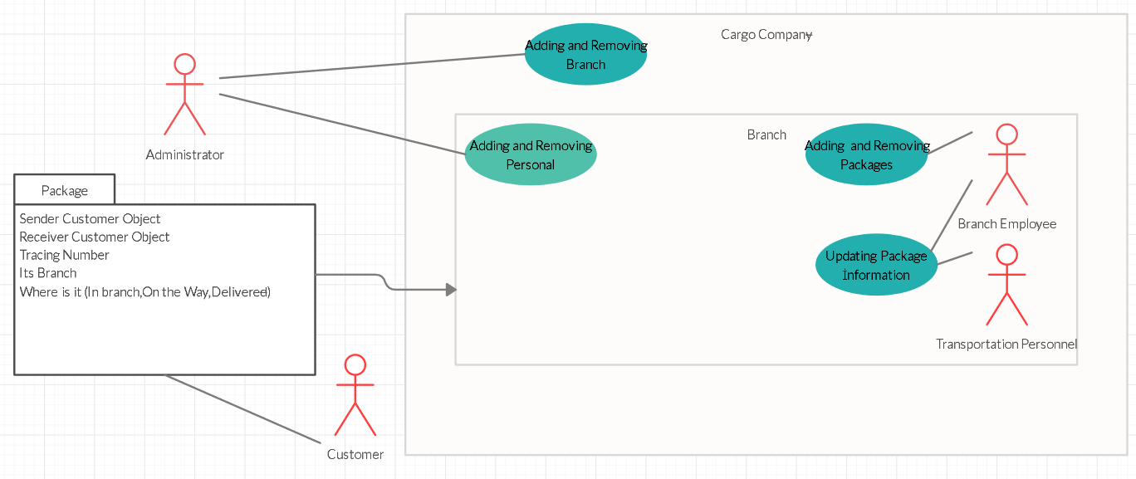
2.Use Case Diagram

3.Class Diagram
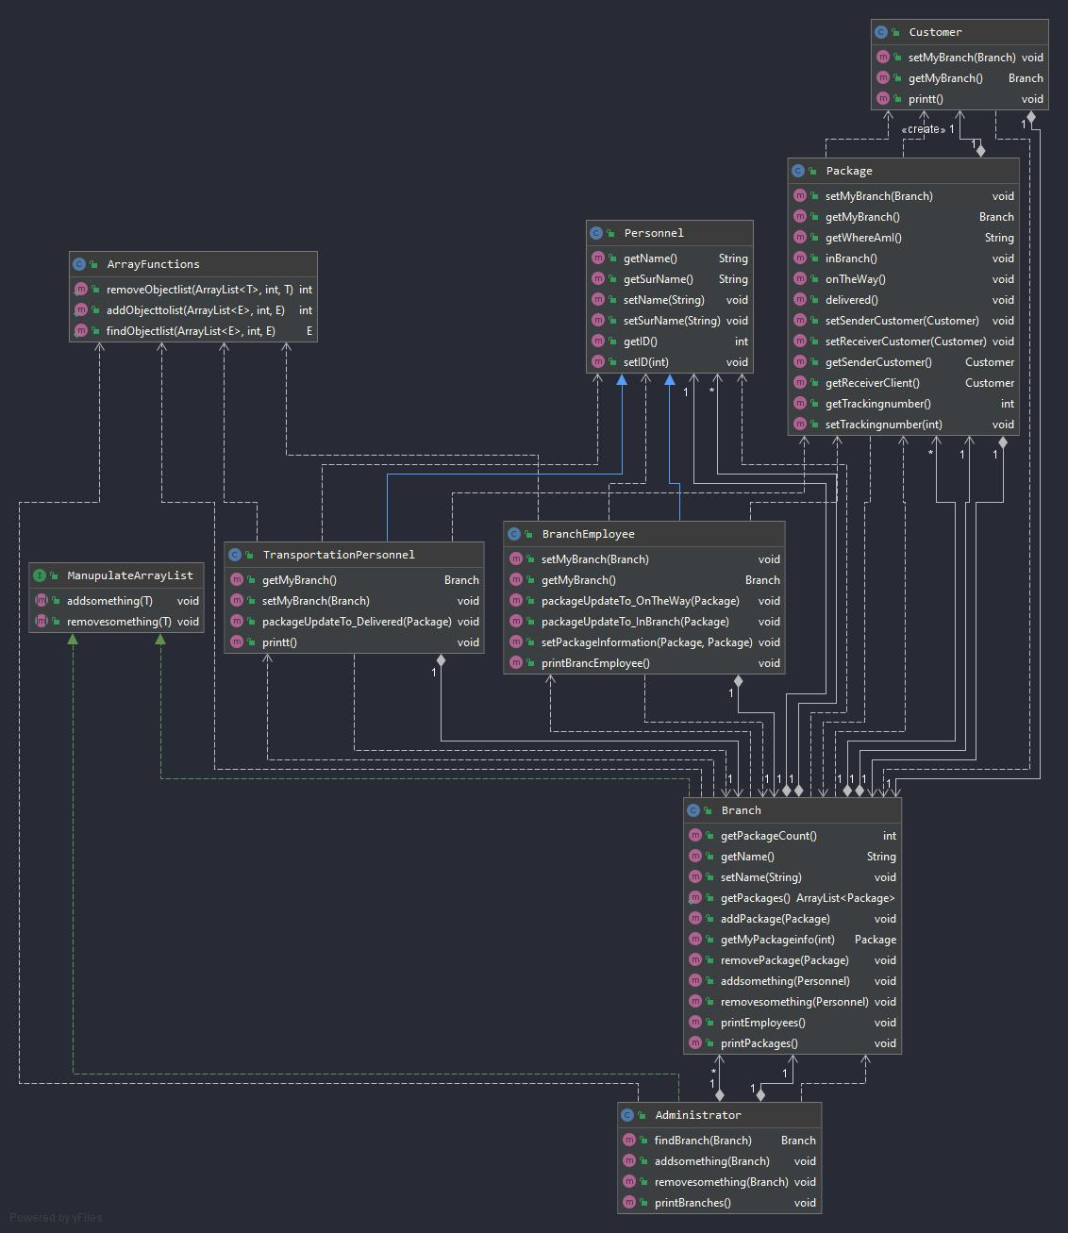

4.Problem Solution Approach

First, branch employee and transportation personnel object data must keep in branch class and they must in same object array that’s why I create personnel type. This personal class is the base class, branch employee and transportation personnel are derived class. The other problem is “Which branch has the package”. Package object have Mybranch variable and its type is Branch. I had to create interface this interface name is ManupulateArrayList, It has two overridden function that’s name is addsomething and remove something, addsomething function is in Branch class and administrator class its adding branches and personnel, removesomething function is in branches class and administrator class, it is removing personnel and branches.

5.Test Cases

This function finding object and deleting it, if it not there they are sending an error message.

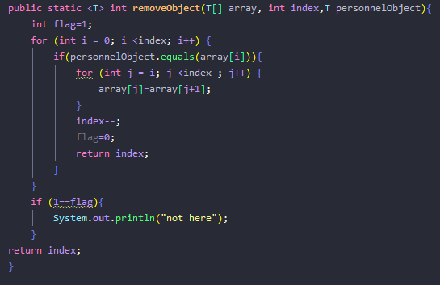

This function Adding object to object array, if that object already there it sends an error message.
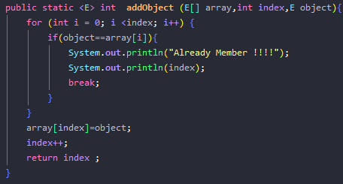

6.Running and Results
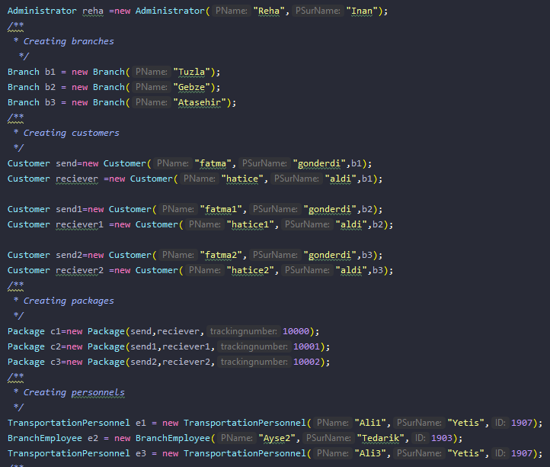
Creating Objects

Main Output

